Add Email Account on Outlook (2016)

1. Go to All Programs -> Outlook 2016

2. Click on Yes and select ‘Next’.

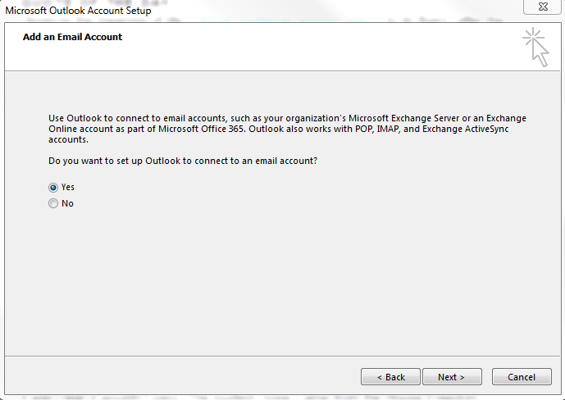

3. Enter your full name, USC NetID and the password. Select ‘Next’.

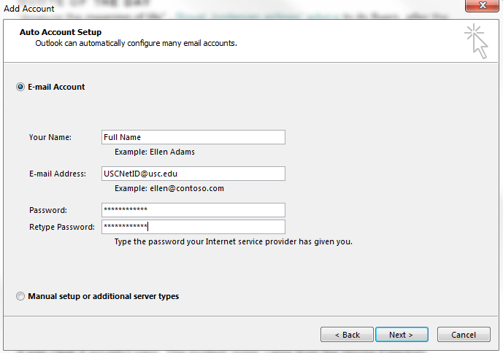

4. When the Organizational Email Account successfully configures click Finish.

