Setting Preferred Name
To edit the preferred name (name that will be displayed in emails):
- Go to http://employees.usc.edu/ on any browser (Chrome/Safari/Firefox).
- The website contains a list of all the applications that can be accessed using the USC NetID. The list should include Workday. Select Workday.
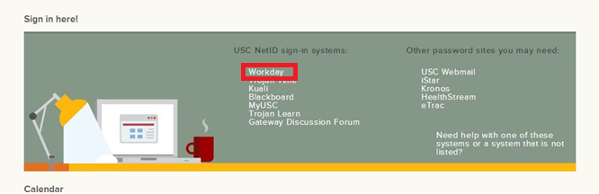
- User will be prompted for the login credentials. Enter USC NetID and password. NetID is the login account used to access Kuali, eMarket, MS 365, etc.
- On the Workday home screen, select Personal Information.
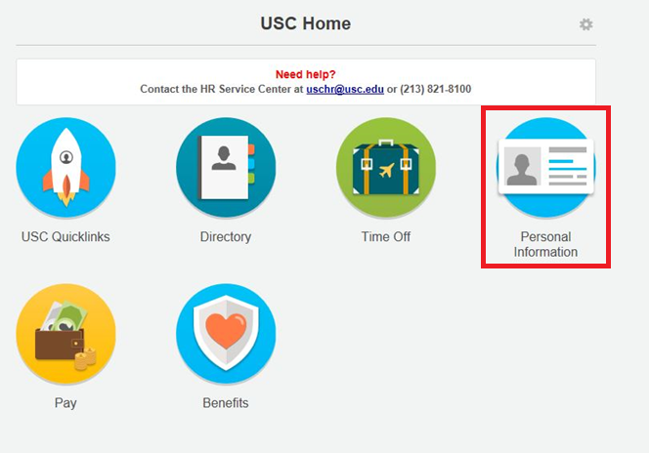
- Click on ‘Preferred Name’.
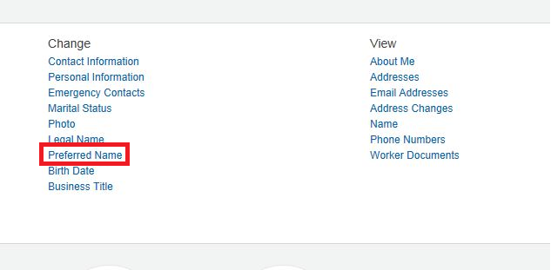
- Uncheck the ‘Use Legal Name as Preferred Name’ checkbox.
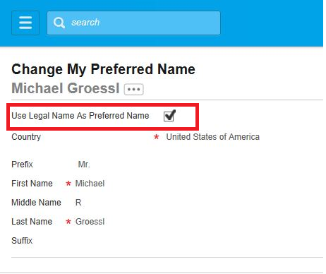
- Edit the details and enter Preferred Name.
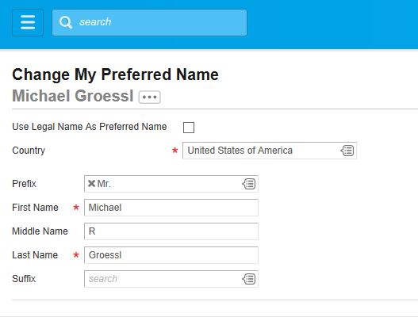
- Submit the changes.
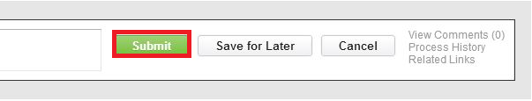
NOTE: It takes up to 24 hours for the changes to be reviewed and approved.

